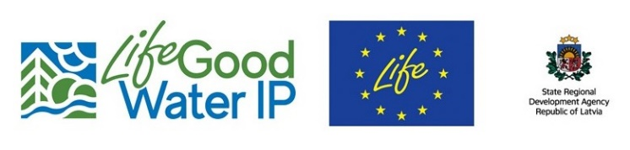
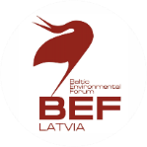

Invitation to the LIFE GoodWater IP international conference on
“Nature-based solutions for improvement of water quality and river basin management”
26-27 October 2022, Riga, Latvia
Aim of the conference: to present the role of nature-based solutions and ecosystem services approaches in improving the ecological quality of water bodies, as well as to share experiences and lessons learned in applying these measures in rural areas. The conference is planned as face-to-face event.

Nature-based solutions (NBS) are defined as actions inspired or supported by nature to address societal challenges and needs. NBS enhance those ecosystem services which can mitigate environmental problems at the same time delivering various co-benefits for society. NBS can be applied in river basin management for improving water quality, water retention and reducing flood hazard, as well as enhancing green & blue infrastructures that promotes biodiversity and provides other benefits.

The conference is organised by the LIFE GOODWATER IP, which aims to improve the status of water bodies at risk in Latvia by implementing the measures laid down in the river basin management plans.

Brief outline of the conference programme:
1st day (Wednesday, 26 October): a field trip to explore the LIFE GoodWater IP demonstration areas for improvement of ecological water quality in the Vidzeme region. The participants of the field trip will meet in Riga (Park Inn by Radisson Riga Valdemara) at 12.00 for a lunch. The field trip will end around 18.30 with dinner in the coastal town Saulkrasti. A shuttle bus will be organised to take participants to the demonstration areas and back to Riga.
2nd day (Thursday, 27 October): conference in Riga Park Inn by Radisson Riga Valdemara from 9.00 till 17.30, including plenary keynote presentations on the NBS concept and ecosystem services framework for water management and its application in LIFE programme projects, as well as parallel session on practical examples for introducing NBS for improvement of water quality in rural areas and water bodies.
Participation at the conference is free of charge. Costs for catering during the conference and field trip will be covered by the LIFE GoodWater IP project. You are invited to register to the conference HERE until 14 October 2022.
Please, see attached the draft agenda of the conference and technical information. There is still a possibility to include few presentations in the parallel sessions, so if you are interested to contribute, please, contact me (anda.ruskule@bef.lv). You are also welcome to share this invitation with your colleagues who might be interested in participating.
On behalf of the seminar organisers team
Dr. Anda Ruskule
Environmental expert/ project manager
Baltic Environmental Forum-Latvia
Event held in the frame of the project "Implementation of River Basin Management Plans of Latvia towards good surface water status" or LIFE GOODWATER IP, project number: LIFE18 IPE/LV/000014, https://goodwater.lv/en/home; FB: @LIFEGoodwaterIP

